Name: v.ramya sri

Reg no: 192124039

Q1>> 8>>

**Out put ::**

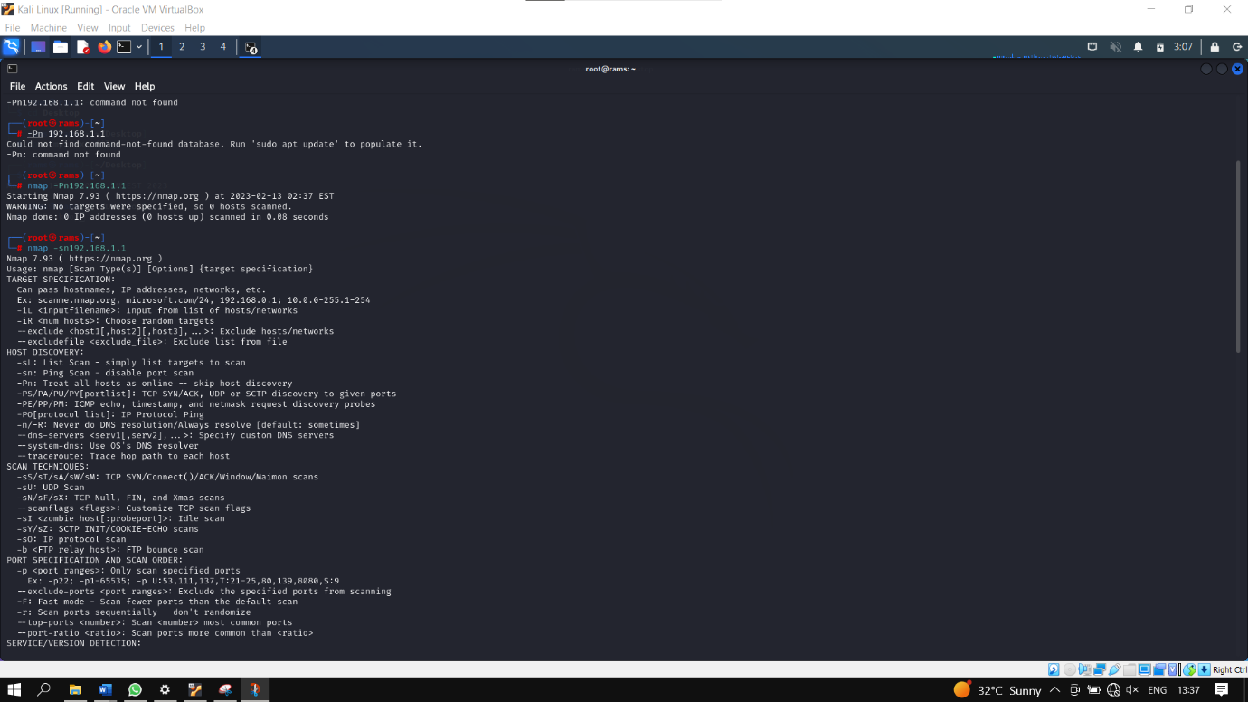

**Q2>>8>>**

**Out put** : :

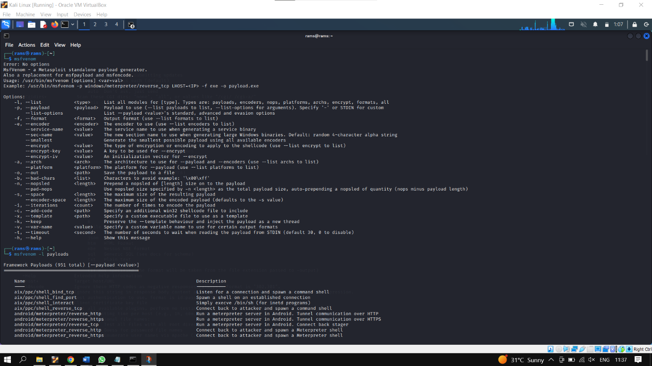

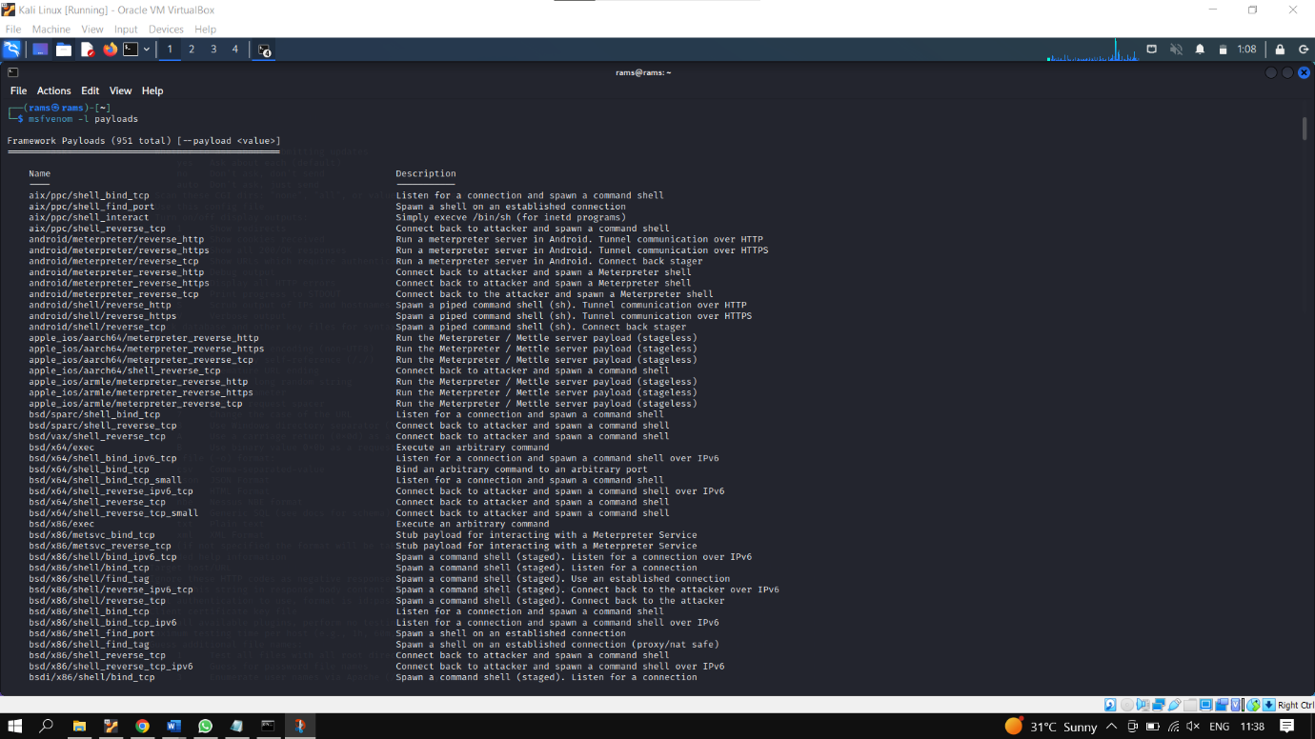

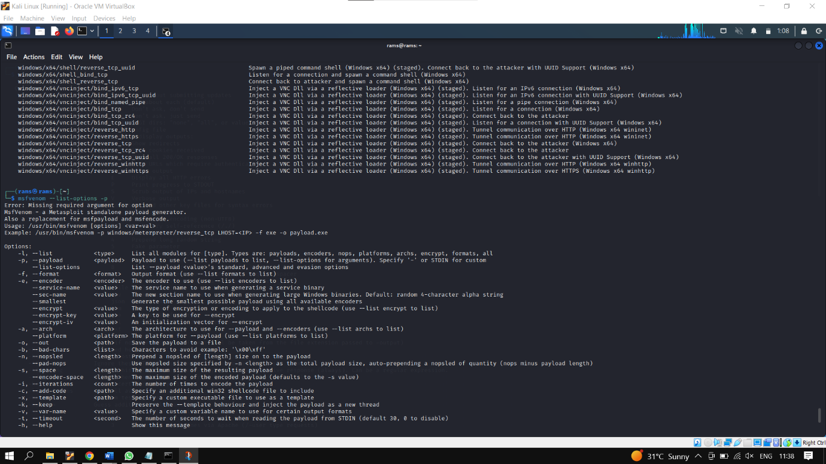

**Q3>>8>>**

**OUT PUT : :**

**Q4>>8>>**

**OUT PUT:**

